
August 2023 Edition
Thank you again for your kind comments about our newsletters, we appreciate the support and feedback. If anyone would like anything included please let us know.
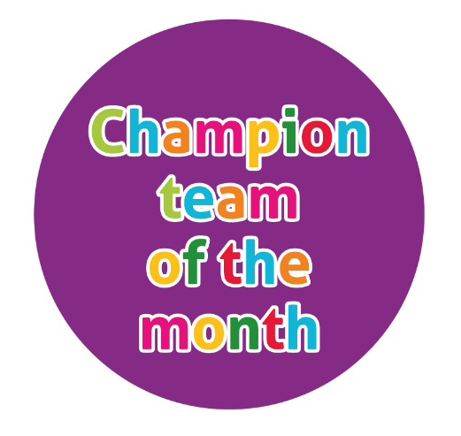
The champion team of July is the ‘Medicines’ team.
Meet the team

Hayleigh Short Megan Williams Louise Harrop

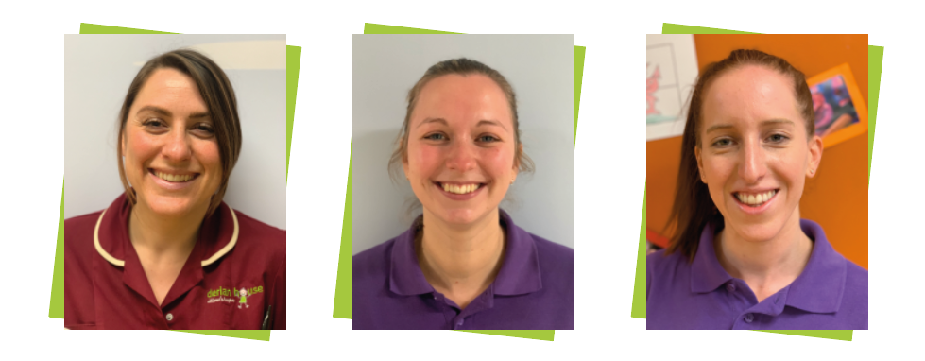


Education Headline News
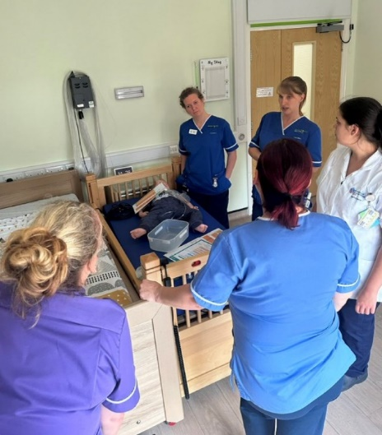
Deteriorating child scenarios
We have commenced the roll out for deteriorating child competency and have completed some
simulations around the hospice. Thank you to those who have engaged so far, please keep a look
out for the sim doll and brush up on your A-E approach and have a read of the current resus
guidelines.

Workshops
The education workshops have been held around the region and been very
well attended. These workshops aim to highlight the work that the education
team are doing on the Lancashire and South Cumbria Babies Children and
Young Peoples Palliative and End of Life Care Education project.
Workshops have been held at Barrow, Preston, Blackburn and Derian House.
Future workshops to be held in Blackpool, Lancaster and Ormskirk.

Thank you to the comms team for our new banners outlining the project and each of its modules. They look amazing and really display the ideas we have for the education project.
Student Nurse
Please welcome our new student nurse, Kerry Oldfield. She is a child branch nurse from UCLAN and is with us for the next 7 weeks. Please say hello, introduce yourself and your role and support her in her learning around the hospice.
Education Compliance
E-learning compliance is at 95% which is amazing, well done everyone! Clinical Competency compliance is 90% which again is really good. Please ensure you know where you’re up to with training, we recently sent out an email with individual education compliance. Come to see the education team if you have queries or need a reminder of what you need to do. Please can shift leaders be mindful of allowing staff to complete training when shifts allow.

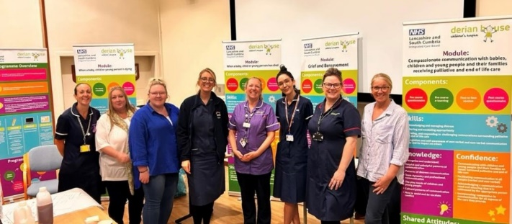

Accountability and professional conduct
Thank to everyone who has attended the accountability sessions, if you have not been to one of these information sessions please see a member of the education team.
These 2 videos are very informative in relation to professionalism in our industry

Focus for the month

Let’s talk about professionalism:
Caring with confidence

https://www.youtube.com/watch?v=1oq9lv8HseQ

Let’s talk about accountability:
Caring with confidence

https://www.youtube.com/watch?v=iMaVr1M-slA


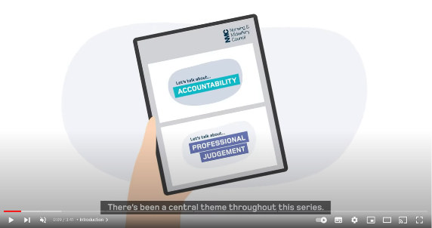
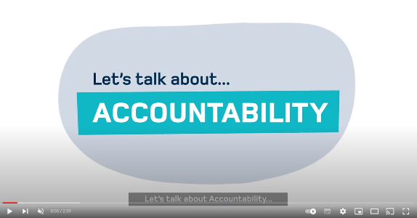


There is an increasing call to provide palliative care alongside disease-directed management. By doing this, clinicians can better address parental concerns, impove parental well-being and boaden the docus of parent-clinician discussions.
Specifically palliative care professionals can support complex decision making, partically regarding advance care planning, and improve the quality of life for children with complex cardiac conditions and their families throughout the illness and not just end of life.

Diagnosis & Treatment
Congenital heart defects are sometimes detected at a routine ultrasound when the mother is pregnant or after birth when symptoms are observed.
Some congenital heart defects in children are simple and don’t need treatment. Other congenital heart defects in children are more complex and may require several performed over a period of several years.
Palliative care delivered in parallel to disease-directed care is recognised as beneficial.
Approx. 15-20% of children with major heart conditions have high-risk complex cardiac conditions. While survival rates for these children have improved, not all have a successful outcome.

Signs & Symptoms
- Breathlessness
- Cyanosis
- Poor feeding or growth
- Tachycardia
- Tachypnea

Facts
- Around5-9/1000 of babies born in England will suffer from some form of congenital heart disease.
- A congenital heart defect is a problem with the structure of the heart that a child is born with. The defect may change normal flow of the blood through the heart, to and from the lungs and to and from around the body.

Congenital Heart Defects

Common complex congenital heart defects

Normal structure
of the heart
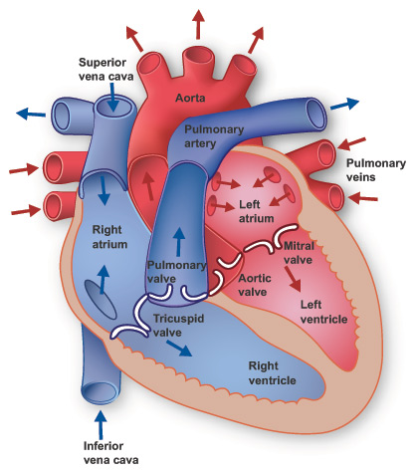
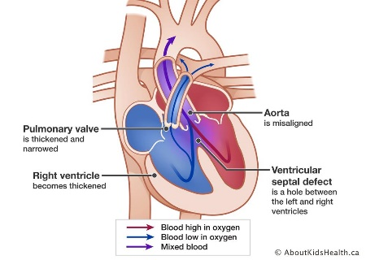
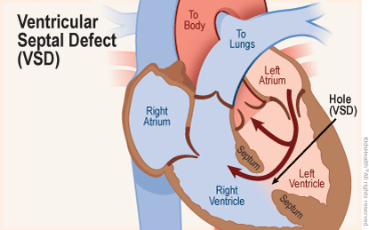
Tetralogy of Fallot
Four abnormalities occurring together

Ventricular septal defect
Hole in the septum that separates the two lower ventricles

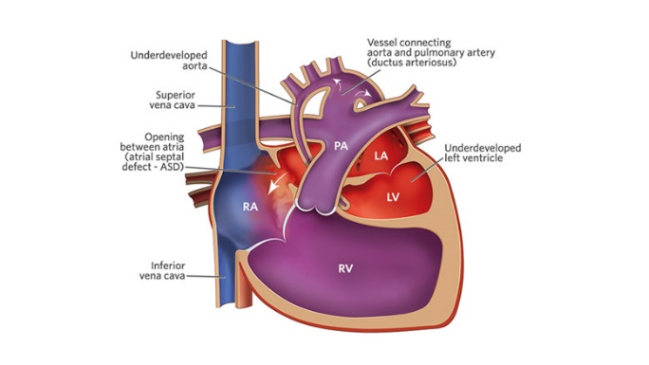
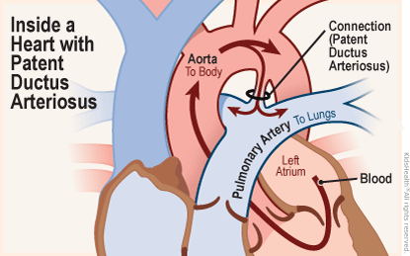

Patent Ductus Arteriosus
The connect between aorta an pulmonary artery does not close at birth

Hypoplastic left heart syndrome
Left side of heart underdeveloped

