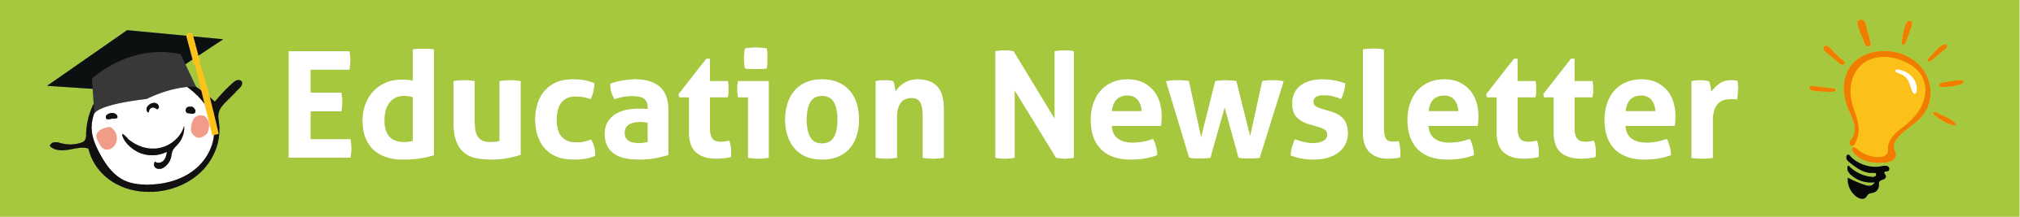
July 2023 Edition
Thank you for all comments on June’s newsletter, we’re glad you liked it and would love to receive further feedback going forward and welcome collaboration from everyone.
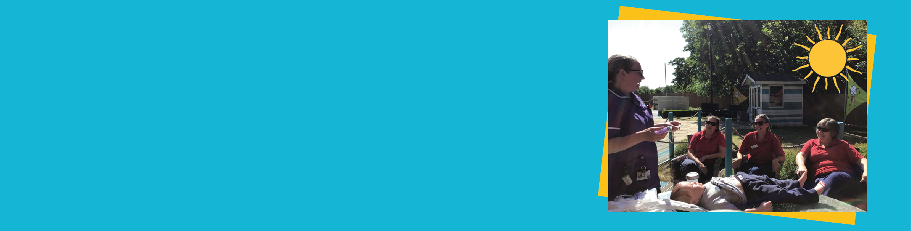
Training in the sunshine!
Alison and the Derian @ Home team made the most of the lovely weather by taking their education outdoors. All that’s missing is a glass of ice cold lemonade!


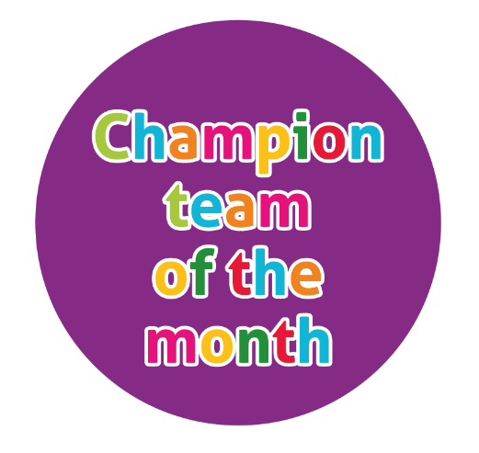
Education Headline News
Education Compliance
E-learning compliance remains high, but there are a few staff who need to complete the Learning Disability
and Autism awareness (Oliver McGowan) course on ELearning for healthcare. When you complete any ELearning,
please send over your report to the educators so we can track it. You can find your report under
My Activity-Reports-Download as PDF

Scan the QR code to access ELearning on your phone/tablet

Clinical Competency compliance is 91%, which again is really good. 100% of staff have now completed their
BLS training but if you want a refresher or practice, just pop up to the skills lab to use the dummies.

In response to incident reporting themes, the senior care team have implemented a 100% compliance target for all nurses and CSW’s to have accountability training, which can be arranged with the
educators.
This training only takes around 30-40 minutes and covers topics such as delegation and incident reporting.

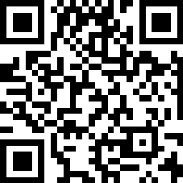

Students
We have a student called Kerry joining us on 17th July for 7 weeks. She is a 3rd year child brand student from UCLan.

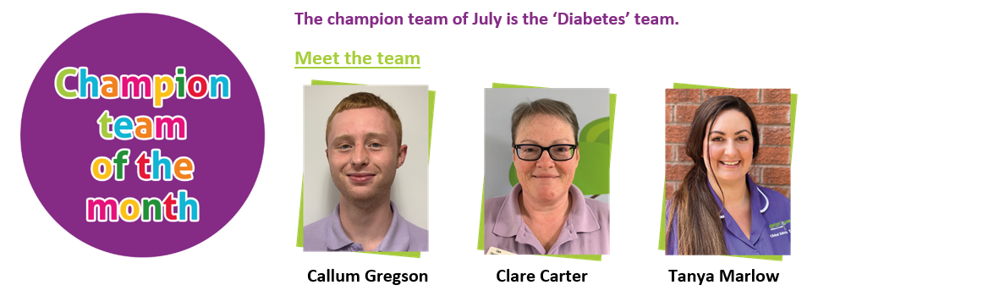

This is a brand new champion team with a wealth of experience of different types of diabetes. The role of the diabetes champion team is to plan for and implement education surrounding any children and young people coming to stay with us and have diabetes. Thank you to Callum for your contribution to the newsletter this month.


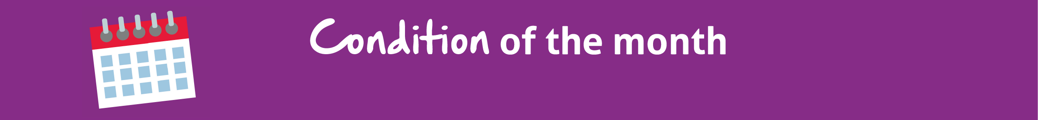
Facts
- In type 1 diabetes, the pancreas cannot produce the hormone called insulin.
- Insulin is needed for glucose to enter the cells for energy.
- Fewer than 1 in 10 people in the UK have type 1 diabetes.
- In most cases, diagnosis happens in childhood but anybody can develop it at any age or time.
- People who have family members with the condition are at a slightly higher risk of developing type 1 diabetes.
- There is no cure for type 1 Diabetes and it is not contagious so you can’t catch it from someone else

Symptoms of high blood glucose (Hyperglycaemia) above 8.5mmol
- Passing more Urine
- Feeling very thirsty
- Feeling sick
- Irritable
- Confusion
- Aggression
- Sweet smelling breath like pear drops

Diagnosis & Treatment
Hypo
Symptoms of low blood glucose (Hypoglycaemia/Hypo) can be treated with glucose juices, glucose tablets or fast acting carbohydrates like pure orange juice, full sugar drinks or sweets. Moderate Hypo’s can be treated with glucose gel which is squirted into the patient’s mouth in the buccal cavity (inside cheek). A severe Hypo can be treated with a Glucagon injection in the thigh. After a hypo, the patient can often feel tired and/or hungry and have a headache it is important to stay with them offering help and reassurance.
Hyper
The main treatment for high blood glucose (Hyperglycaemia/Hyper) is a dose of insulin. If their glucose levels go very high or stay high for too long the person can start to have high levels of Ketones. If their glucose is above 14.0 mmols then we should test for Ketones using a Ketone monitor.
DKA
A risk of very high blood glucose is Diabetic Ketoacidosis which is a life threatening emergency and requires hospital treatment. This is treated with a balance of IV fluids with glucose, sodium and potassium and an insulin infusion. Usually patients in DKA are very sick and nursed in a HDU setting. DKA can be triggered by sickness, stress and infections.

Training
The QR codes will take you to training videos for Dexcom continuous glucose monitors (CGM) and omnipod insulin pods
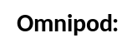
Symptoms of low blood glucose (Hypoglycaemia) below 4mmol
- Looking pale
- Sweating/ clammy
- Shaking
- Feeling hungry
- Confused
- Tearful
- Becoming angry or aggressive
- Seizure
- Falling asleep/ looking dazed

Signs & Symptoms

Diabetes

0

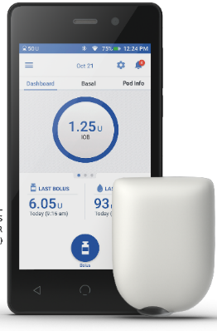
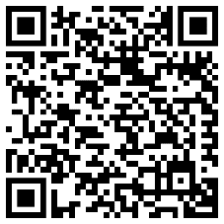

Dexcom:
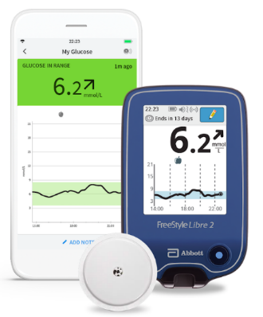
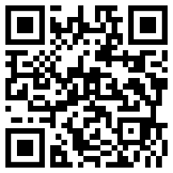

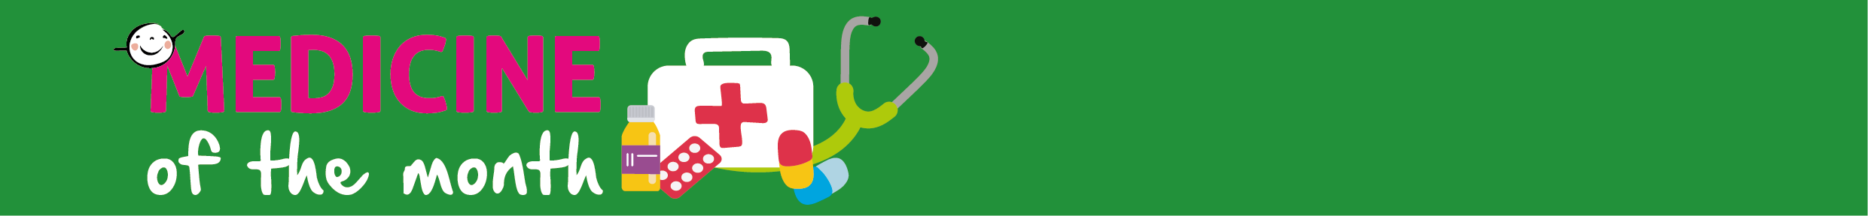
All about insulin
Insulin is a natural hormone which is made by your pancreas which helps the cells in
your body to use the glucose from the food we eat. Doses of insulin are measured in
units.

As those with type 1 diabetes are unable to make their own insulin, they need to
inject it to control the level of glucose in their blood. This can be administered by an
insulin pen or by an insulin pump which is attached to the patient usually in their
thigh, tummy or arms and these are changed once every 3 days (72hours).
It is really important to rotate injection sites to avoid lumps under the skin called
cutaneous amyloidosis.

Blood Glucose monitoring
Blood glucose levels are monitored using a blood glucose meter by using a drop of blood from a finger prick to test with a blood glucose monitor. Another way is a Continuous Glucose Monitor (CGM). This checks their blood glucose automatically at regular intervals (such as every 10 minutes) and can send alarms to the meter that comes with it or a mobile phone if the blood glucose levels are rising too high or dropping too low.

Different types of insulin
Some people have set volumes of short acting insulin (such as Novorapid, Actrapid, Humalin) to take with meals and as a correction dose to lower their blood glucose levels when it is too high. Many also need a set dose of long acting insulin (such as Lantus, Levemir, Tresiba) before bed to keep their blood glucose levels steady when they sleep at night.

Carbohydrate counting
A lot of people with type one diabetes use a method called carbohydrate counting to determine their dose of insulin with meals and snacks. They can use an app or device to calculate how much insulin they need according to their blood glucose levels and the grams of carbohydrates in their food and drink.

Insulin

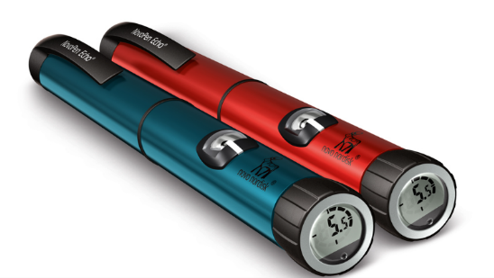

If you would like to get involved with planning the content for next month’s newsletter, please speak to the education team or email clinical.education@derianhouse.co.uk

