
June 2023 Edition
Welcome to the new Education newsletter, designed to keep you up to date with what is happening within Derian House and equip you with the knowledge to provide the best care for our service users and families.



Meet the team:

Kirsty, Education Manager
Email me at:
Kirsty.blackburn@derianhouse.co.uk
Alison, Clinical Practice Educator
Email me at:
Alison.morris@derianhouse.co.uk
Tanya, Clinical Practice Educator
Email me at:
Tanya.marlow@derianhouse.co.uk


Education \\\\\\\\\\Headline News

Students
We have two second year child branch student
nurses called Saskia & Richard and a second year LD nursing student called Lisa, all from UCLAN.

They will be on placement from 19th June for 4 weeks and will be spending time across the care team, Derian at home and perinatal team and can spend time within all the different areas at Derian. They have been allocated their off duty and mentors. Please give them a huge warm welcome into the team and show them the ropes.

ELearning
ELearning compliance is at 96%, which is amazing, well done everyone!
Clinical Competency compliance is 88%, which again is good. Jane is doing a fantastic job with vent training.
Please ensure you know where you are up to with training, come to see the education team if you have queries or need a reminder of what you need to do. Please can shift leaders be mindful of allowing staff to complete training when shifts allow.


The champion team of June is the ‘Deteriorating child’ team.
We are looking for a nurse or CSW to join the team so please contact us if you are interested.
The deteriorating child champion team will be working with the educators to do simulation training over the next few weeks so
keep a look out for the sim doll
and brush up on your A-E approach
and have a read of the current
resus guidelines.

The team is made up of Faye,
Ruth and Kirsty.




Anaphylaxis

Anaphylaxis is a severe and potentially life-threatening whole-body allergic reaction, which can occur when a person is exposed to trigger/allergen.
Reactions usually begin within minutes and progress quickly but can be delayed a few hours after exposure to the allergen.
Anaphylaxis is the result of the body’s immune system over reacting to a harmless substance and releasing a flood of chemicals such as histamine, cytokines and enzymes to protect itself, which causes constriction of smooth muscle, dilation of blood vessels and an increase of vascular permeability. This leads to a major fluid shift in the body, swelling, hypotension and hypovolemic shock.
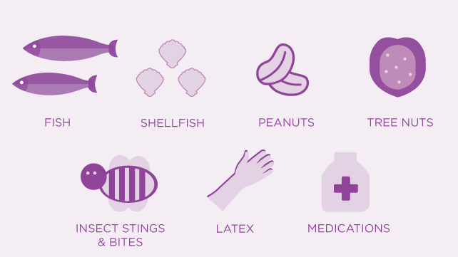
Causes
Anaphylaxis triggers can be categorized into 4 groups; food, drugs, venom & idiopathic (which means no clear trigger found). Some of the more common triggers include; Wheat, eggs, fruits, insect venom, chickpeas, dairy, medicines, shellfish, peanuts, balloons and latex. It is more common for children to be allergic to foods and for adults to be allergic to medicines (NICE, 2021).

Further Reading
- Anaphylaxix.org website Education | Anaphylaxis UK
- NHS Website Anaphylaxis - NHS (www.nhs.uk)
- Guideline & Algorithm Emergency treatment of anaphylactic reactions: Guidelines for healthcare providers | Resuscitation Council UK

Diagnosis & Treatment
A diagnosis is usually made based on the presenting signs and symptoms and followed up with a blood test.

Adrenaline in the form of an Epipen or IM adrenaline (1mg/ml) should be administered at onset and repeated within 5 minutes if no improvement.

Signs & Symptoms
- Swelling in the throat, tongue, face and upper airways, hoarse voice, difficulty swallowing.
- Sudden onset wheezing, breathing, noisy breathing.
- Dizziness, feeling faint, sleepiness, confusion, pale clammy skin, loss of consciousness
- Red raised rash, hives, urticarial across the body
- Tingling or itchy mouth
- Swollen lips, face or eyes
- Stomach pain or vomiting


Adrenaline

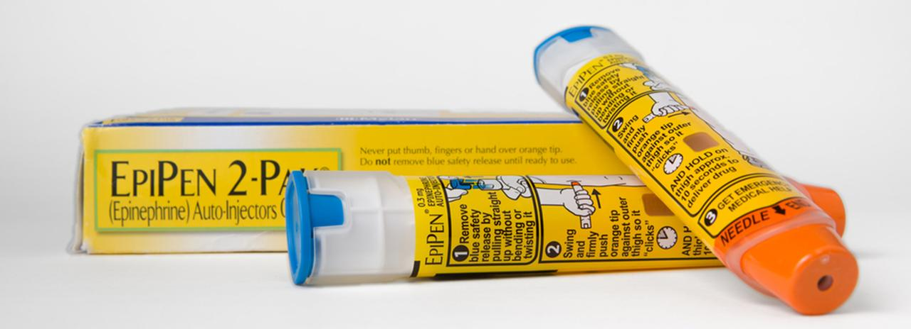
Indication
Adrenaline (epinephrine) is a hormone naturally produced in the body, which helps the body prepare for stressful or dangerous situation, is used in emergencies such as during CPR, severe croup and anaphylaxis.
It is usually injected intramuscularly, intravenously or inhaled by nebulizer and works to increase heart rate and contractility of the heart. It can cause vasoconstriction or vasodilation. At Derian house, you may need to administer IM adrenaline in the form of an Epipen if a child or young person had an anaphylaxis reaction.
Adrenaline increases peripheral vasoconstriction, bronchodilation, reduces angioedema and reduces the release of inflammatory mediators to reverse anaphylaxis.
Dosage
- Anaphylaxis IM adrenaline 1mg/ml (1:1000) concentration
- Adult and Child >12 years: 500mcg (0.5ml)
- Child 6-12 years: 300mcg (0.3ml)
- Child 7 months- 6 years: 150mcg (0.15ml)
- Child <6 months: 100-150mcg (0.1ml-0.15ml)

How to administer an Epipen:
How To Use: Administering Your EpiPen® | EpiPen®
‘Blue to the sky, orange to the thigh’

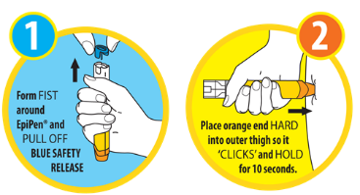

Side Effects
- Anxiety
- Headache
- Insomnia
- Tremor
- High blood pressure
- Nausea
- Vomiting
- Palpitations

See BNF/BNFC for more information Adrenaline/epinephrine | Drugs | BNFC | NICE

