

Business Continuity Plan
Version | Author | Changes | Status
1.0-1.7 | Vanessa Spinks / Luke Bateson | As detailed in business continuity plan reference latest update May 2021 saved on the Facilities Q Drive | Approved
1.8 | Luke Bateson | - Removal of Confidentiality.  - Removal of policy wording and accountability to a policy.  - Restructure as documented within the Table of Contents.  - Inclusion of Operation Derian | Approved
1.9 | Luke Bateson | - Update of SMT contact details  - Update to Evacuation Procedure  - Update to Relocation of Staff properties  - Changes to agreed delegated authority
1.10 | Catherine Randall / Kim Owen | - Update of SMT & Director information  - Change of commissioning demographics  - Abbreviations changed

Table of Contents
- Introduction
- Objectives
- Roles and Responsibilities
- Procedure
- Operation Derian
- Action Plans and Checklists
- Relocation of Staff
- Evacuation Procedure
- Site Plans
- SMT/Key On Call Contact Details
- Communications Protocol
- Delegated Authority

1. Introduction
This plan sets out how Derian House Children’s Hospice (referred to as Derian House throughout this plan) will ensure that its critical activities can be maintained during a disruptive incident, such as denial of access to premises, high levels of staff absence, loss of utilities and Information Communication Technology failure. The board of trustees have an overall oversight of this plan. Responsibilities for the effective operation sits with the Chief Executive, Directors and Senior Management Team.
2. Objectives
The objectives of this plan are:
- To manage the charity effectively in the event of a crisis so as to cause minimal human, financial and environmental loss or damage
- To continue to serve children and young people (CYP) and families, including the safe transfer of CYP
- To enable the charity to recover to its original position before the catastrophic event
- Identify critical operational functions being in or out of service.
TO ACTIVATE THIS PLAN IMMEDIATELY GO TO SECTION 6 PAGE 7
Questions regarding the content or application of this plan should be directed to the Head of Facilities and Infrastructure.
3. Roles and Responsibilities
3.1 Chief Executive
The Business Continuity Lead is the Chief Executive or in her absence any of the three Directors. The Chief Executive is responsible for delegating the responsibility of all aspects of business continuity with the full support of the Senior Management Team and the Board of Trustees. They are responsible for the following:
- Assuming full management of the crisis
- Ensuring the emergency services have been informed
- Ensuring that all SMT members have been informed
- Ensuring the incident has been communicated to all employees by their Senior Manager
- Ensuring the incident has been communicated to suppliers
- Informing utility companies of the incident
- Ensuring that employees are provided with medical assistance if required
- Making reports to the Health and Safety Executive if required
- Ensuring recovery site is equipped appropriately
- Assessing or appointing an assessor for damage and salvage
- Providing the Marketing and Communications Officer with updates as required
- Chairing progress meetings during incidents
- Ensuring this plan is regularly tested and reviewed with audit trails to provide assurance.
3.2 Directors & Senior Management
The Directors & Senior Management Team are responsible for ensuring they understand their key actions and responsibilities within their department. All Directors & Senior Managers are to keep a hard copy of this plan, with a digital copy held electronically on the senior management q drive and the intranet to ensure that in the event of loss of the building, there will be continued access to this plan.
3.2 Most Senior Staff on Site
This person is the most senior member of staff in the building at the time of the incident who escalates this incident to the Head of Facilities and Infrastructure and Chief Executive.
4. Procedure
The prioritisation in dealing with damage to premises or denial of access is to be addressed in the following order:
- Safety of all babies, children, young people, (BCYP) families and personnel. No attempt should be made by personnel to enter, examine, repair or otherwise deal with any damaged area of premises. This must be left to the emergency services, approved contractor or trained personnel. Entry to the building for approved contractors or trained personnel will only be authorised by the Head of Facilities and Infrastructure.
DO NOT ENTER DAMAGED PREMISES – IF IN DOUBT, EVACUATE IMMEDIATELY FOLLOWING THE EVACUATION PROCEDURE
- Notify the emergency services, the Head of Facilities and Infrastructure or the most senior member of staff. In an emergency, if you are the first person to discover the incident, call the emergency services immediately then notify the Head of Facilities and Infrastructure who will deal with the incident.
- The fire evacuation process must be invoked immediately (see section 8 for full details)
- Security of the premises and contents. In the interest of safety and security, the damaged area or the perimeter of the premises should be lock-fast at the earliest opportunity. Provided it is safe to do so, the Head of Facilities and Infrastructure or delegated Estates personnel should remain in attendance until they have been secured.
- Temporary or permanent repairs. Temporary or permanent repairs shall be arranged by the Head of Facilities and Infrastructure using approved contractors or trained Estates personnel.

The following table outlines what would trigger the use of the Business Continuity Plan. This is important because it determines when you need to escalate for wider support. Review the incident levels. If unsure escalate early.
Incident Level | Description | Included Examples but not limited to: | Plan Activation | Escalation
1 – Low level incident | This level would consist of routine building issues which can be dealt with within business as usual (BAU) measures and will not impact upon any critical activities/services. | Leaks, spills, generic maintenance issues | No | Escalation should stay within local limits of building users to ensure BAU capabilities are met. Estates department to be notified.
2 – Moderate level incident | Loss of non-critical activities/services due to a minor disruption or incident which will not impact on critical activities/services. | Local flooding, local IT failure, telecoms disruption | No  Should be managed as BAU by SMT affected  YES  Should disrupted services require further resource or site support, this plan may be activated to support their response. | Most Senior person on site escalates to their Line Manager. Head of Facilities and Infrastructure to be notified.
3 – Significant level incident | Loss of critical activities/services due to a disruption or incident which has a potential to affect services provided for a prolonged period of time [more than one day] but will need the co-ordination of a senior manager. | Utility failure, damage to site, restricted access to site, partial loss of key suppliers, infection outbreak, lack of staff to deliver service | No  If only partial or potential affect to critical activities/services. To be managed by SMT affected with preparedness to plan activation.  YES  This plan will be activated to support the response to disrupted services. Decision to be made to activate Operation Derian (Section 5 of this plan) | Most Senior person on site escalates to the Head of Facilities and Infrastructure. Escalation required to CHIEF EXECUTIVE to activate plan or notify of preparedness to activate plan.
4 – Extreme level incident | Loss of critical activities/services due to a disruption or incident which is expected to last more than the expected recovery time and may cause risk to patient and staff safety. | Fire in building resulting in evacuation, Severe weather conditions causing damage to site and access issues, complete prolonged IT or Utility failure, External Major incident | YES  This plan will be activated to support the response to disrupted services. Decision to be made to activate Operation Derian (Section 5 of this plan) | Most Senior person on site escalates to the Head of Facilities and Infrastructure. Escalation required to CHIEF EXECUTIVE to activate plan.
5. Operation Derian (BCYP Evacuation Plan)
Operation Derian refers to the evacuation plan for BCYP in the care of Derian House. This plan details the responsibilities of Derian House and Lancashire Teaching Hospitals NHS Foundation Trust in the event of evacuation. Action Plan 6.5 on page details the responsibilities for Derian House staff specifically.
TO INVOKE OPERATION DERIAN PLEASE GO TO ACTION PLAN 6.5 ON PAGE 11
This evacuation plan has been approved by the EPRR Committee at Lancashire Teaching Hospitals NHS Foundation Trust on January 13th 2022 and passed to the divisional management team for women’s and children’s and is saved and accessible locally within Lancashire Teaching Hospitals NHS Foundation Trust
The Lancashire Teaching Hospitals NHS Foundation Trust board operator shall alert:
Lancashire Teaching Hospitals NHS Foundation Trust Chief Operating Officer / Executive Director on call, Head of Patient Flow and the Senior Paediatric Nurse on duty to explain that Royal Preston Hospital has been asked to received evacuated BCYP from Derian House under the plan.
Once the plan is invoked, a core management team, consisting of Derian House staff, Lancashire Teaching Hospitals NHS Foundation Trust Chief Operating Officer / Executive Director on call, Head of Patient Flow, the Senior Paediatric Nurse on duty and North West Ambulance Service (NWAS) Liaison Officer assigned to Royal Preston Hospital will work together to manage the response.
Appointed Derian House staff will accompany the BCYP during transfer and will remain at Royal Preston Hospital to provide the correct level of care., until all BCYP have been repatriated or admitted.
Uninjured BCYP will remain the clinical responsibility of Derian House throughout this process.
Derian House will be responsible for making contact with the BCYP family members. Communication facilities shall be provided at the Royal Preston Hospital.
Press and Communications Officers (or nominated deputies) for each Derian House and Lancashire Teaching Hospitals NHS Foundation Trust will liaise with one another and nominate a lead spokesperson to ensure that all information passed to the media is managed between all parties.

6. Action Plans and Checklists
6.1 Immediate Actions (1-3 hours)
Action |  | Owner | In Progress | Complete
1 | Invoke evacuation procedure? | Head of Facilities and Infrastructure
2 | Inform Chief Executive | Head of Facilities and Infrastructure
3 | Inform SMT and Chair of Trustees a level 3 or 4 incidence has been declared | CEO
4 | Ensure medical assistance is provided to the injured and emergency services contacted | Head of Facilities and Infrastructure / CEO
5 | Ensure that gas, water and electrics are switched off if necessary | Head of Facilities and Infrastructure
6 | Ensure United Utilities are informed if flooding has occurred | Head of Facilities and Infrastructure / CEO
7 | Consider invoking Operation Derian if BCYP are in our care. Refer to section 5 of this plan. | Director of Clinical Services (Chief Nurse) / CEO
8 | Ensure teams are aware of the Communication Protocol | Directors & Management Team
9 | Issue press release and prepare website if necessary | Director of Income & Engagement
10 | Hold progress meeting to assess situation and action plan for next phase | CEO

6.2 Short Term Actions (4-8 hours)
Action |  | Owner | In Progress | Complete
1 | Obtain damage assessment report from emergency services if necessary | Head of Facilities and Infrastructure / CEO
2 | All non-essential staff are sent home awaiting further instructions if necessary | Directors & Management Team
4 | When safe to do so assess what can be salvaged if necessary | Head of Facilities and Infrastructure / CEO
5 | Contact\establish recovery site following assessment of requirements if necessary | Head of Facilities and Infrastructure / CEO
6 | Contact appropriate suppliers to inform them of incident | Head of Facilities and Infrastructure / CEO
7 | Inform insurance company with current details | Head of Facilities and Infrastructure / CEO
8 | Progress meeting to assess situation and action plan for next phase | Head of Facilities and Infrastructure / CEO

6.3 Long Term Actions (8-12 hours)
Action |  | Owner | In Progress | Complete
1 | Assess what can be salvaged if necessary | Head of Facilities and Infrastructure / CEO
2 | Arrange transportation of salvaged goods to another premises if required | Head of Facilities and Infrastructure / CEO
3 | Ensure HSE informed of any injuries or serious incidents | Head of Facilities and Infrastructure / CEO
4 | Inform - Lancashire South Cumbria Integrated Care (ICB), Greater Manchester ICB, CQC, NHS England North West, Department of Health, Emergency Planning team | CEO/ Director of Clinical Services (Chief Nurse)/ Head of Governance and Compliance
5 | Communication protocol followed ensuring that all employees not at work are informed of the incident | Directors & Management Team
6 | Visit recovery site to identify any additional facilities which are required (refer to Section 7 of this plan) and to source emergency IT equipment if required | Head of Facilities and Infrastructure / CEO
7 | Co-ordinate with SMT what additional facilities and wellbeing requirements may be needed | Head of Facilities and Infrastructure / CEO

6.4 Long Term Actions (12-24 hours)
Action |  | Owner | In Progress | Complete
1 | Obtain latest report from emergency services if appropriate | Head of Facilities and Infrastructure / CEO
2 | Ensure that debris or damage removal company are informed so dangerous materials can be removed if required | Head of Facilities and Infrastructure / CEO
3 | Issue further press release if required | Director of Income & Engagement
4 | Inform/Update insurance company | Head of Facilities and Infrastructure / CEO
5 | Hold progress meeting to assess situation and action plan for next phase | Head of Facilities and Infrastructure / CEO

6.5 Operation Derian Actions
Action |  | Owner | In Progress | Complete
1 | Delegate the repatriation process to a suitable member of staff. If possible, make arrangements for BCYP to be transferred to their home by collection or Derian House transfer. If this is not possible, refer to the next action. | Director of Clinical Services (Chief Nurse) / CEO
2 | Ascertain if the safe transfer of BCYP can be completed by Derian House or, if NWAS require contacting, make contact. Keep a record of transferred BCYP | Director of Clinical Services (Chief Nurse) / CEO
3 | Obtain staffing requirements to support the evacuation. | Director of Clinical Services (Chief Nurse) / CEO
4 | If BCYP require transfer to Royal Preston Hospital, contact the switchboard on 01772 716565 and invoke the Derian House Evacuation Plan; giving details of the number and medical requirements of BCYP being evacuated. | Director of Clinical Services (Chief Nurse) / CEO
5 | Provide a liaison for NWAS staff to coordinate transport arrangements. | Director of Clinical Services (Chief Nurse) / CEO
6 | Ensure the BCYP for transfer have their medical records, prescription charts, and any other items required to be with them. Where possible, medical devices and current medications can be transferred with them. | Director of Clinical Services (Chief Nurse) / CEO
7 | A suitably qualified member of Derian House staff must accompany the BCYP at all times | Director of Clinical Services (Chief Nurse) / CEO
8 | If required, should CYP be residing in the sunflower room. Contact should be made with the local funeral director for the repatriation of the body. | Director of Clinical Services (Chief Nurse) / CEO
9 | Once the Derian House site is clear, report to the Royal Preston Hospital (RPH) Patient Flow Office (bed hub, in occupational therapy unit, off Burgundy Street) to coordinate the ongoing situation with RPH staff. | Director of Clinical Services (Chief Nurse) / CEO

7. Relocation of Staff
The relocation of an operational base for staff shall be to one of the following locations and shall be dependent on the nature and impact of the incident and the nature of employee duties. The Head of Facilities and Infrastructure shall lead this process with full support from all Senior Management
- Work from home
- Vinten Place
- Chorley Retail Shop
- Preston Retail Shop
- Blackburn Retail Shop
- Horwich Retail Shop
- Leigh Retail Shop
- Warehouse
- Derian on Holiday Lodges
All volunteering is to be suspended until further notice. The Director of People & Organisational Development shall manage this notification.

8. Evacuation Procedure
Derian House Children’s Hospice Core Hours 8am-4pm Mon-Fri Fire Evacuation Procedure

If you discover a fire:
Immediately raise the fire alarm by activating the nearest alarm call point. These are located around the building and can be found by all exit doors

Responsibilities | Description
Evacuation Control Team (ECT) | An individual person or team of persons taking full control of the evacuation process.
Fire Marshal (FM) | A designated person allocated a specific zone of the building to marshal.
Essential Person | An individual or team with responsibility for the direct care of a child or young person (CYP).
Non-essential Person | All personnel that do not have the responsibility to provide direct care for CYP. This includes visitors and contractors.

On hearing the fire alarm (continuous alarm)

Non-essential person actions:
- Leave the building calmly, safely and as quickly as possible via the nearest exit. Do not collect possessions.
- If there is smoke from under or above a door or if the door feels hot itself, do not open the door.
- Safely assist in the evacuation of allocated visitors. Please refer to the Visitor Policy for further detail on who is responsible for visitors.
- Report to the designated assembly point on the path adjacent to the main car park entrance and await the roll call.
- Do not leave the assembly area until the Evacuation Control Team gives permission.

Essential person actions:
- Ensure only essential persons responsible for the care of the BCYP stay with the BCYP. Instruct others to evacuate.
- Prioritise external evacuation to the designated assembly point on the path adjacent to the main car park entrance.
- If BCYP is unable to evacuate: Ensure you and BCYP are within a protected area between fire doors but away from the area of any imminent danger (detectable smoke, fire, or unusual odour)
- Consider horizontal evacuation *. If the area you are in becomes unsafe, relocate to a safe distance (i.e. another wing, the opposite end of the corridor, or outside) with two fire doors between the source of the alarm and the place of safety.
- Communicate to the Evacuation control Team via the Fire Marshall the decided course of action and the location including potential horizontal evacuation routes.
* Horizontal evacuation refers to the means of moving away from an area of danger to a safer place on the same floor.

Evacuation Control Team (ECT) actions:
- Collect a radio and proceed to the main reception fire panel. In the event of a fire in the main reception area or immediate location, revert to the secondary control panel.
- Contact all fire marshals via radio Channel 1 to state the location of the alarm. Repeat this communication.
- Situate externally to ensure radio communication is audible. Remain visible and accessible to Fire Marshals.
- Confirm all Fire Marshals have completed their actions and record communication.
- Communicate with Lancashire Fire and Rescue to either call off the service or confirm required attendance.
- Conduct roll call at the assembly point.
- Liaise with Lancashire Fire and Rescue, detailing all Fire Marshal communication and details of any essential medication to be collected from treatment rooms.
- Inform evacuated personnel when it is safe to re-enter the building
- Ensure timings of all events are noted and produce a full evacuation report post incident.

Fire Marshal actions:
- Collect a radio and turn to Channel 1.
- Put on a hi-vis jacket.
- Listen for the fire location from ECT. Contact ECT if not received prior to marshalling of area.
- Conduct a visual inspection of the designated area to confirm any signs of fire.
- Ensure that all non-essential personnel leave the area quickly and calmly
- Report any signs of fire or any other issues immediately to the ECT via radio.
- Capture information from essential personnel including names and location of the personnel staying within the building and the detail of their horizontal evacuation plan.
- Shut all doors in the area as passing through to prevent the spread of smoke and fire
- Leave the building and report findings to ECT in person.

Derian House Children’s Hospice Out of Core Hours Fire Evacuation Procedure

If you discover a fire:
Immediately raise the fire alarm by activating the nearest alarm call point. These are located around the building and can be found by all exit doors

Responsible Persons | Description
Evacuation Control Team (ECT) | An individual person or team of persons taking full control of the evacuation process.  - For the Main Hospice, this must include the most senior member of the Care Team  - For Vinten Place, this must include the most senior member of the staff
Essential Person | An individual or team with responsibility for the direct care of CYP.
Non-essential Person | All personnel that do not have the responsibility to provide direct care for CYP. This includes visitors and contractors.

Non-essential person actions:
- Leave the building calmly, safely and as quickly as possible via the nearest exit. Do not collect possessions.
- If there is smoke from under or above a door or if the door feels hot itself, do not open the door.
- Safely assist in the evacuation of allocated visitors. Please refer to the Visitor Policy for further detail on who is responsible for visitors.
- Report to the designated assembly point on the path adjacent to the main car park entrance.
- Do not leave the assembly area until the Evacuation Control Team gives permission.

9. Site Plans
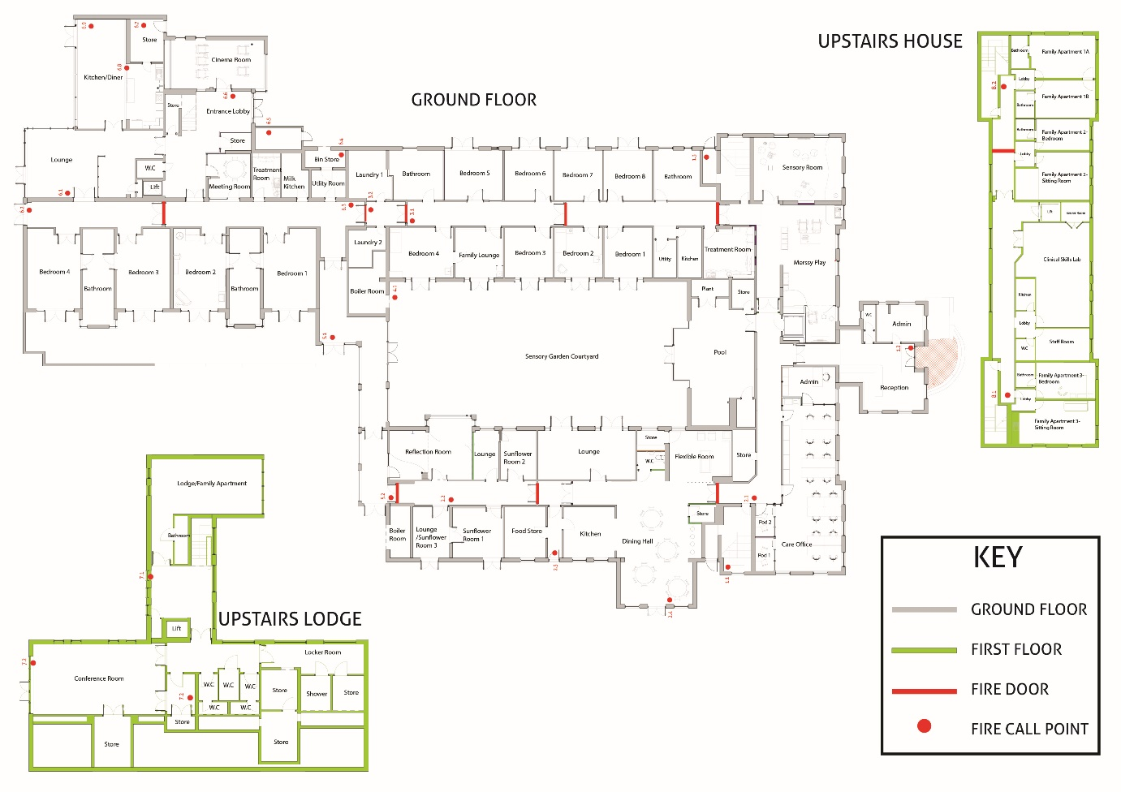
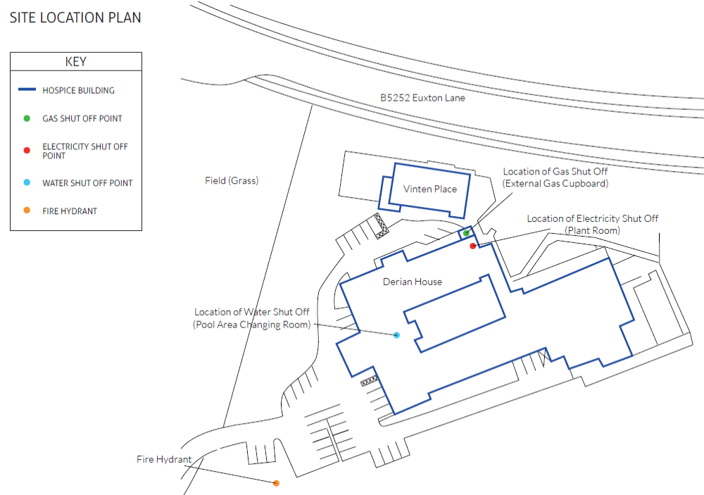

10. SMT/Key On Call Contact Details
Plan activation Key On call contacts / SMT Emergency Contact List
Role | Name | Contact Number | Alternative Contact Number
CEO | Karen Edwards | 07787 254993
Director of Clinical Services / Chief Nurse | Catherine Randall | 07795521071 | 01772 877600
Director of People & Organisational Development | Kim Owen | 07557 781941
Director of Income and Engagement | Caroline Taylor | 07968730738 | 01772 499298
Head of Facilities and Infrastructure | John Boe | 07307 213366
Head of Finance | Colin Taylor | 07804 976107
Head of Governance and Compliance | Anthony Mohammed | 07789 015870
Head of Retail and Online Sales | Mick Croskery | 07772 422838

Delegated Authority Trustee Contact Details
Role | Name | Contact Number | Alternative Contact Number
Chair of Trustees | Karen Swindley | 07989 551484 | 01772 387651
Vice Chair of Trustees | Helen Rotheram | 07888 799966
Vice Chair of Trustees | Matthew Cowburn | 07793 048190 | 07949 189991

11. Communications Protocol
Should a Level 3 or 4 incident be declared then the following communication actions should be followed:
Chief Executive declares L3/4 incident

Communicate to SMT with timescales for return if known.

SMT to inform ALL members of their team who are not at work.

To ensure consistency when informing staff, and to reduce the impact of any misinformation, the following agreed communication is to be used:
“There has been an incident (fire/water/gas leak etc) at Derian and as such we have declared an emergency. Please do not come to work. You will be notified with arrangements on when you will be returning to work and where that may be. Please do not talk to press as this is being co-ordinated centrally and please do not post on social media. We will contact you with any further action so please do not try and contact the Hospice. We will be in touch as soon as possible – Karen Edwards, CEO at Derian House”
If required, the Director of Income and Engagement shall assess appropriate communications outside of Derian House in coordination with the Chief Executive.

12. Delegated Authority

Authority is delegated from the Chief Executive to the Senior Management Team when they are not available to give authority. This maybe in the circumstances of extended leave or in an emergency situation when they are unavailable.
The table below outlines who can take responsibility for decision making should the Chief Executive be incapacitated for an extended period of time or uncontactable. For example, where normally the Chief Executive would provide authority, this would require approval from Chair of Trustees plus two SMT members as indicated below. Should the suggested delegate also be absent or uncontactable then another member of the SMT may step in to replace that individual.
Authorisation Required By: Priority 1-3
 | Care | Facilities | I.T | Finance | HR | Fundraising | Communications / Marketing | Emergency Control Priority 1-3  (Where control has to be taken in emergency the following members of SMT will take overall management in the following order replacing activities allocated to Chief Executive Officer in BCP)
Chair of Trustees | 1 | 1 | 1 | 1 | 1 | 1 | 1
Vice Chair of Trustees | 2 | 2 | 2 | 2 | 2 | 2 | 2
Director of Clinical Services / Chief Nurse | 1 | 2 |  | ✓3 | 2 |  |  | 1
Head of Facilities and Infrastructure | ✓2 | 1 | 1 |  |  |  |  | 1
Head of Finance | ✓3 | ✓3 | ✓3 | 1 | ✓3 | ✓3 | ✓3 | 2
Head of Governance and Compliance |  |  |  | 2 |  |  |  | ✓3
Director of People & Organisational Development | ✓3 |  | 2 |  | 1 |  | 2 | ✓3
Director of Income and Engagement |  |  |  | 2 |  | 1 | 1 | ✓3
Head of Retail and Online Sales |  | ✓3 |  |  |  |  |  | ✓3

